# *Development Project I (420-E50-HR)*

# *Assignment 09 – Project Inception and Product Backlog*

Date assigned: Thursday, October 12, 2017

Date due: **Part A,B – (individual) Monday, October 16, 2017, 11:00 p.m.; Computer Science late policy applies**

**Part C – (group) Monday, October 16, 2017, 8:00 a.m.; Late Assignments will not be accepted.**

**Learning Objectives**

Upon successful completion of this assignment, the student will be able to:

* Create an inception deck for a development project
* Describe how the Scrum process can be implemented using Team Foundation Server
* Write a list of user stories for a development project
* Split large user stories into smaller user stories that can be prioritized

To do:

Part A,B are individual components of this assignment.

Part C is a team activity. I recommend you do Part C first.

**Part A – Inception Deck**

1. This part of the assignment is to be completed individually for the assigned project.
2. Using the tool of your choice, draw a **context** diagram for your system. The following links can be used for additional help on how to draw the diagram:

<https://www.lucidchart.com/pages/data-flow/context-diagram-example>

<https://support.office.com/en-us/article/Create-a-data-flow-diagram-509a0489-4b63-479c-84ae-4cd5bc7c896d>

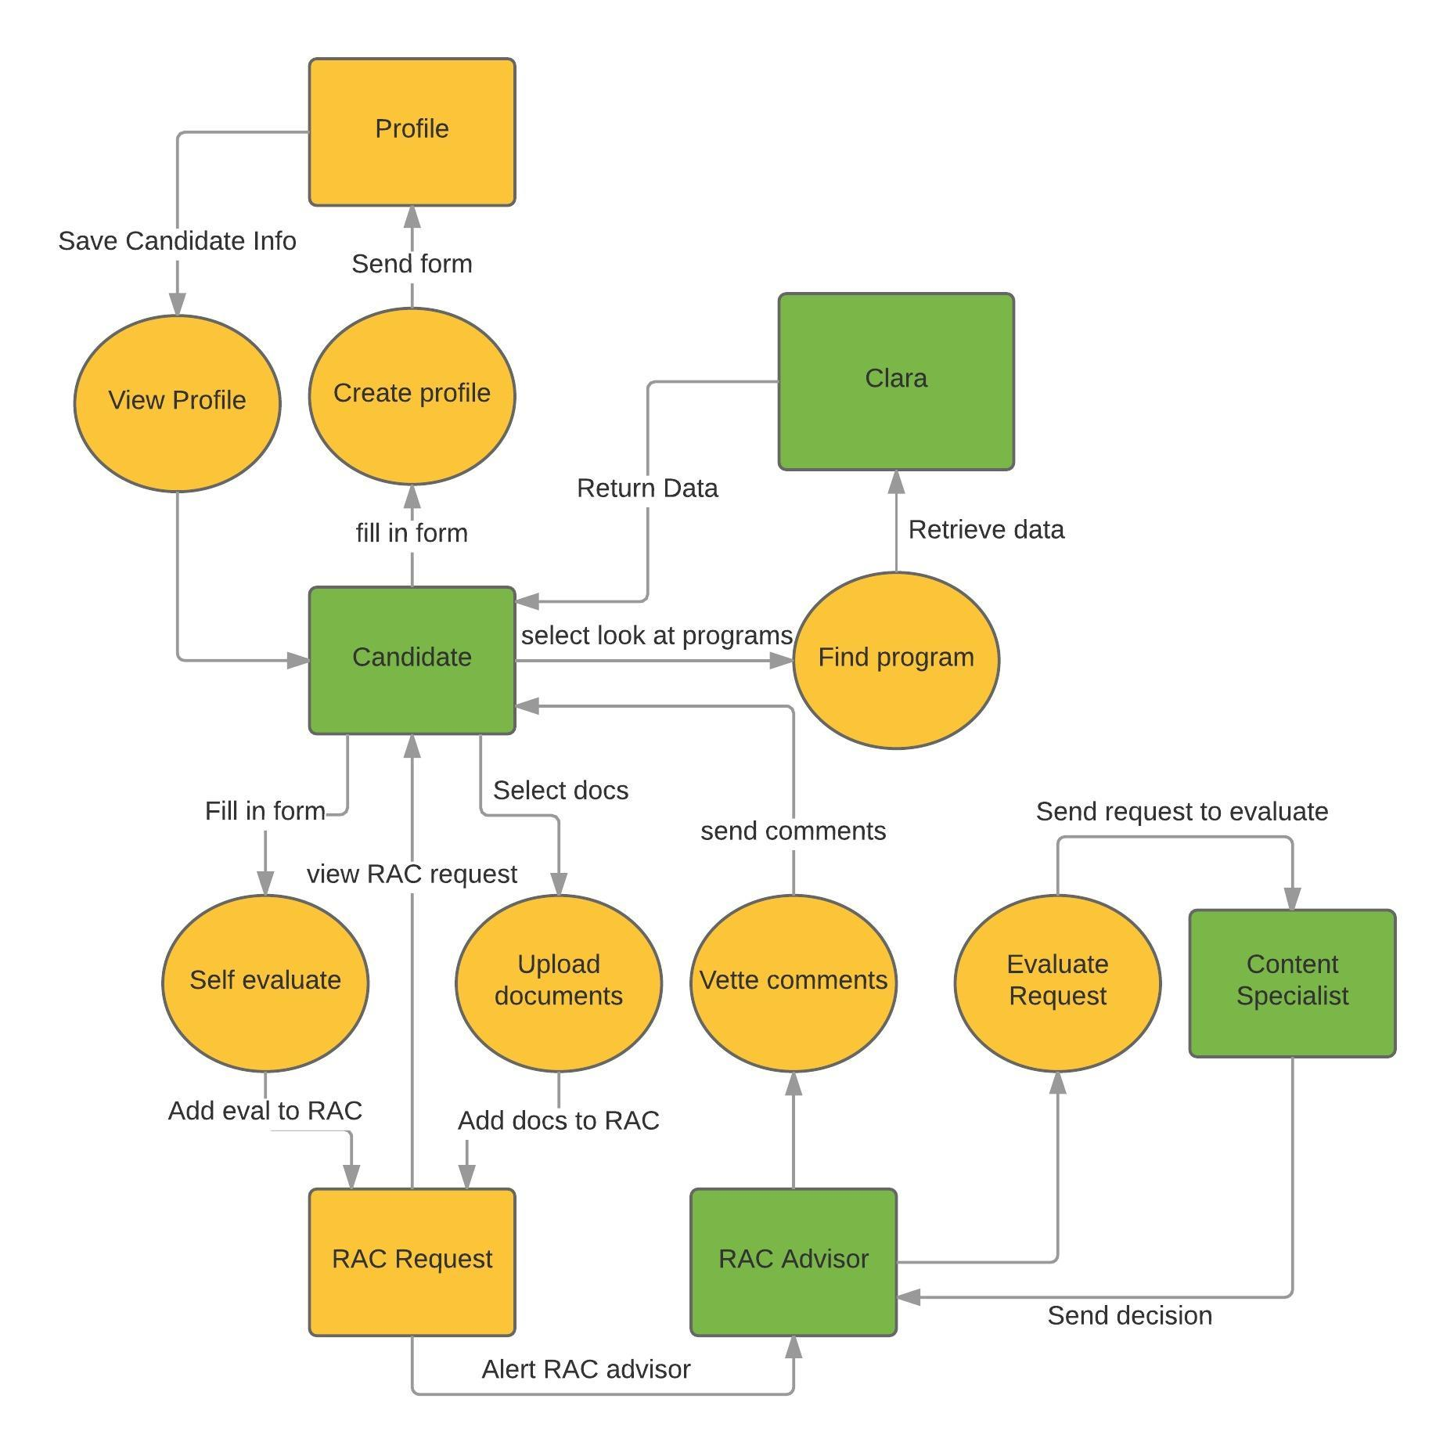

1. Open the Inception Deck PowerPoint presentation from Moodle. Using the information from the site <http://agilewarrior.wordpress.com/2010/11/06/the-agile-inception-deck/> and the comments below each slide, create an inception deck for your project. Note that this slide deck has fewer slides than the example on the site.
2. Add your context diagram to the System Context slide.
3. Save the presentation as **YourUserName_E50_A09_Inception.pptx** in your folder for this course. Upload the document to Moodle.

**Part B – Scrum Process**

1. This part of the assignment is to be completed individually. Save this document with the name **YourUserName_E50_A09_Scrum.docx** in your folder for this course.
2. Watch the following YouTube video, which is about 71 minutes long, on *How to implement Scrum using Team Foundation Server*: <https://www.youtube.com/watch?v=9MRbY8RqQdU>. Answer the following questions:
   1. What are three advantages of agile over traditional plan driven development?
      1. Simple end-to-end functionality is achieved at an early stage.
      2. Regular testing throughout the system
      3. Each component gets gradually richer features and behavior. High confidence in product from an early stage.
   2. List the three roles in Scrum. Who are the people in each of those roles for your project?
      1. Product Owner – Alain
      2. Scrum Master – Richard
      3. Development team – Andrew, Brae, Cody, Louis, Max, Philip
   3. List the three artefacts in Scrum. Which role is responsible for each of the artefacts?
      1. Increment
      2. Product backlog – Product owner
      3. Spring backlog – Development team
   4. List the five events in Scrum.
      1. Sprint
      2. Sprint planning
      3. Daily scrum
      4. Review
      5. Retrospective
   5. How many steps are there in the SSW Steps to Scrum?

8 steps

* 1. What is a PBI? What are the four types of PBIs?
* Product Backlog Item:
  + - 1. Features
      2. Technical work
      3. Bugs
      4. Knowledge acquisition
  1. What are the states for a PBI in TFS?
     1. New
     2. Approved
     3. Committed
     4. Done
     5. Removed
  2. How should the user’s answers to questions be recorded?

They should be recorded very simply, in the language used by the user, and then turned into PBIs if it’s appropriate for that item.

* 1. What can be used to group PBI’s?

Burndown charts

* 1. Given that there are 6 hours of class time and 3 hours outside class time to work on sprints and that you should have something visible to demonstrate at the end of each sprint, how long should the sprints for your project be? What should be recorded as the Capacity per Day?

With a team of 6 people, 9 hours a week is 54 man-hours a week. This means in 2 weeks you have 108 man-hours – or about 3 weeks of full-time work for one person. With 6 people on the project, there’s a lot more delays in decision making and communication, so 2 week sprints seems appropriate.

* 1. Who is involved in identifying the tasks for a sprint item?

Everyone

* 1. What three states are shown in the Board in TFS?

Approved, done, in progress

* 1. Should your project use the feedback tool? Why or why not?

The feedback tool isn’t necessary for our team I don’t think. Our team is small, we’re all located in the same place and we have our retrospective meetings. On top of that, we also already use the TeamMates software to allow us to provide feedback, so I don’t think that the TFS version of this will be necessary to use.

**Part C – Product Backlog Construction (group)**

1. Meet as a team to review the user stories that were developed in assignment 5. Refer to the following web site to split any of the large user stories into smaller user stories: <http://blog.agilistic.nl/10-useful-strategies-for-breaking-down-large-user-stories-and-a-cheatsheet/>
2. Enter the product backlog for your project in the web client for Team Foundation Server using the following link: <http://cstfs.cegep-heritage.qc.ca:8080/tfs>. Include a title with the short form of the user story (i.e. without the last “so that…” clause). If applicable, include a screen image of the content from the existing documentation. Add any acceptance criteria, including questions for the user.
3. Add any technical work, such as designing the user interface, or knowledge acquisition items, such as researching reporting tools, to the backlog.
4. Do an initial triage of the product backlog and sequence it (i.e. Assume you have 2 sprints (of 2 weeks each), order the product backlog). Ensure that, as a team, you identify where you think you can get to in 2 sprints (i.e. the n-th item in the backlog). For these items, provide rough estimates (using sprint points), and acceptance criteria.
5. You will be meeting with the product owner next week to:
   1. Validate the items, sequence and priorities
   2. Q&A for any acceptance criteria or requirements that you’re still not clear on.

You will use the TFS Backlog screens as a discussion tool with the product owner.

You will capture minutes from the meeting and update TFS accordingly.

Note: do **not** break into detailed-level work tasks (i.e. unit test, code, etc.), this will happen in the sprint planning. At this point, we’re just setting up the product backlog and the initial release.

**Part D – Peer Evaluation**

1. An online Team mate assessment will be sent to you via email indicating when it will be due (Monday Oct 16 11:55pm).

**To submit**

When you have completed the assignment:

Upload:

1. **YourUserName_E50_A09_Inception.pptx**, **YourUserName_E50_A09_Scrum.docx** zipped together into Moodle
2. TFS is updated with your product backlog and complete with any changes from the user.
3. Minutes from the user meeting has been mailed to all invited and also submitted to Moodle **Team*x*_E50_A09_ProductBacklogMeetingMinutes.docx**